**Data Immersion**

**Achievement 6: Advanced Analytics & Dashboard Design**

**Exercise 6.1. Sourcing Open Data**

**Unemployment in America, per US State since 1976**

**Emin Cerit**

**Data Analytics**

**Executive Summary**

This Dataset represents relevant population statistics and employment rates per US state since January1976 until **December 2022.** All data are official figures from the Bureau of Labor Statistics that have been compiled and structured by Justin Oh and published on Kaggle (see link below for details).

**Data Sources**

Open Data Source: [Unemployment in America, Per US State | Kaggle](https://www.kaggle.com/datasets/justin2028/unemployment-in-america-per-us-state)

**Limitation and Ethics**

* **Only states and areas. No cities.**
* **No data about sectors and branches.**
* **No data about professional groups.**
* **This Dataset doesn’t contain any ethical concerns.**

**Data Cleaning and Data Consistency Checks**

* **Renamed columns for better understanding.**
* **Checked consistency. No missing and duplicates found.**
* **Changed some variable’s data type.**
* **Added 4 new columns.**

**Data Profile**

**Number of rows: 29.892**

**Number of columns: 15**

**Column Details**

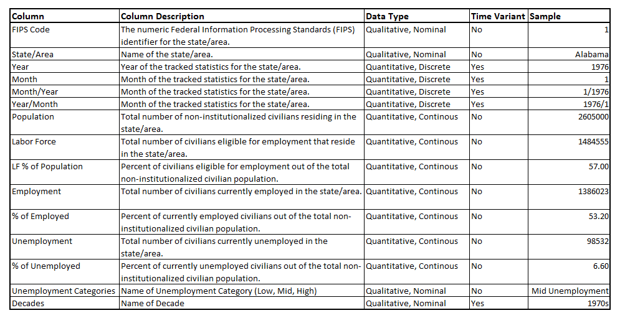

**Questions to Explore**

**How has the unemployment rate in the USA fluctuated over the years since January 1976?**

**Can we see how the economic crises influenced the unemployment rate?**

**Which states and areas have the highest unemployment rate?**

**Which states and areas have the lowest unemployment rate?**

**How does the Labor force and Population correlate with the unemployment rate?**